Technical Report
To: Kuhfahl, Freda (H USA). Lynch, Jim (H USA). Thornton-Maynard, Lakendria (H USA). Foley, Curtis (H USA). Bianco, Diane (H USA). Willmann, Todd (H USA)
CC: Serroels, Randy (H USA). Park, SungSik (Kevin) H CP US - SLS. Lynch, Timothy (H USA). Lynch, Patrick (H USA). Fleischman, Lynne (H USA)

From: Kim, InYoung in PLM transducer
Date: 21. Feb. 2012
Title: Resert XL HLD evaluation report with Siemens transducers

- Executive Summary :
Resert XL HLD is brand new high-level disinfectant and not listed in Siemens Transducer Disinfectant compatibility matrix. It has hydrogen peroxide(H₂O₂) active ingredient. Evaluation result is all probes except VF13-5 tested in 5 representative transducers has passed. This memo will be a justification of updating Resert XL HLD.

- Background :
Customers want to use High-Level Disinfectant(HLD) with Peracetic Acid(PA) and Hydrogen Peroxide(HP) in the field. However Transducer disinfectant matrix in Siemens does not much cover HLD with PA and HP. Resert XL HLD has brand new one in Siemens matrix disinfectant and it will cover High-Level disinfectant with HP in Siemens matrix, if the evaluation pass the chemical soaking test. So this evaluation test will cover HLD with HP for customers.

- Analysis : Resert XL HLD
Resert XL from Resert company is High-Level disinfectant with Hydrogen Peroxide of active ingredient. Its concentration is 1.4% to 2.3% of Hydrogen Peroxide active ingredient. HLD with HP in Siemens disinfectant matrix is not higher than Resert XL so that it should be evaluated in Long-term soak test point of view.

- Scope :
This evaluation test will cover all Siemens transducers. Firstly transducers produced in Siemens, not OEM transducers, will start evaluation test.

- Verification test criteria : Materials Requirement of GTRS (P/N 7297265)
- Test procedure : Transducer Disinfectant Qualification Protocol (P/N 5931980)

  - Chemical compatibility test procedure : see Test Procedure below.
  - High-Level Disinfectant for long-term soak test : Resert XL HLD (active ingredient : 1.4%~2.3% of Peracetic Acid)
  - Soaking Transducers : 4C1(8258525), 15L8(8242295), EC9-4(8648029), P4-2(8648045), VF13-5(10030614)
: Test probes above are representative probe using same contact material as like below.

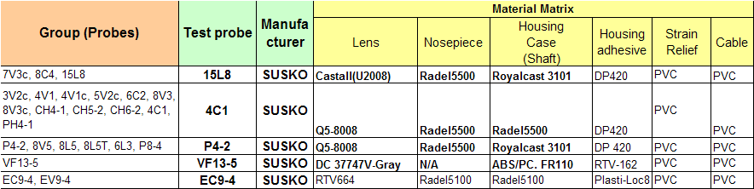
Table1. Probes containing tested probe and contact material

- Strain Relief manufacturers in probes are very different, even though they use same PVC material point of view.

- Test equipment
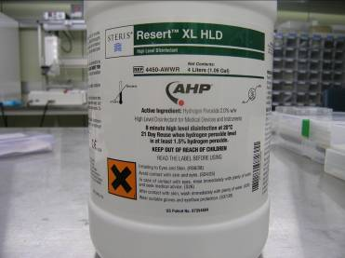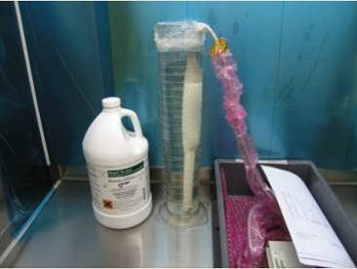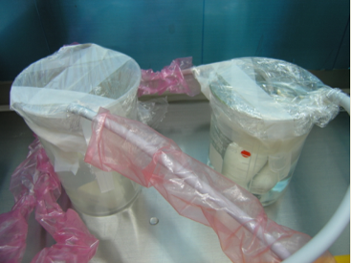
Resert XL HLD Soaking test(EC9-4) Soaking test(Linear/Curved)

- Test Result
Transdcuer | Hipot/  Leakage | Cosmetic  Inspection | Acoustic | Result | Remark
15L8 | Pass | Pass | Pass | Pass
4C1 | Pass | Pass | Pass | Pass
P4-2 | Pass | Pass | Pass | Pass
VF13-5 | Pass | Fail | Pass | Fail | Check the failure at Strain Relief
EC9-4 | Pass | Pass | Pass | Pass

- Conclusion:
As following the test result, only VF13-5 has failed at long-term soak test in test probes. Others are passed and will be updated compatible transducers with Resert XL HLD.
Failure area of VF13-5 is Strain Relief, even though it use same Strain Relief material with P4-2. In addition, 14L5, VFX13-5 use PVC, however manufacturers of Strain Relief for 14L5 & VFX13-5 are different with VF13-5. Therefore next scope is to evaluate VF13-5 and other transducers not evaluated for chemical compatibility for Resert XL HLD.
For actual validation of Resert XL HLD, the transducer disinfectant compatibility matrix will be updated in the intranet site below.

https://intranet.healthcare.siemens.com/cms/USD/en/Departments/PLM/Transducer_Reliability/Pages/High-Level_Disinfectants.aspx

- Technical datasheet about Resert XL HLD
- Technical Documents.

Technical Data Monograph Aquatic toxicity study

- MSDS of Resert XL HLD

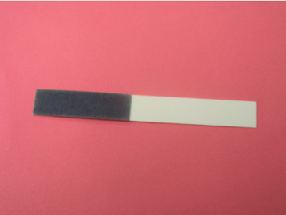
Test strip : It shows Resert XL HLD is active

- Test Procedure
: refer to the Transducer Disinfectant Qualification Protocol (P/N 5931980)

Disinfection reliability test is Pre-cleaner soaking for 7 days at room temperature in the long-term soak test level.
Test procedure was to cover the probe with a wipe thoroughly so that any other things could not go out and into. Then, let it leave at room temperature for 24hours. This process is repeated 7 times. Finally, the probe is inspected by test criteria, and then compare before and after result.

1). Long-Term Soak Test Procedure :
Please refer to the long-term soaking test procedure in the Long Term Soak Protocol of Transducer Disinfectant Qualification Protocol (P/N 5931980) for specific procedure.

- High-Level Disinfectant
Pre test before soaking (Hipot/Leakage, Cosmetic inspection, Acoustic) → soak the transducer into the High-Level Disinfectant → leave it at room temperature for 500hrs → clean it and dry → Post test

2). Pass/Fail Criteria :
In order for a disinfectant to be qualified for use with a particular transducer group, the long term soak and cyclic disinfection exposures:
  - Must not cause the test transducer to fail Hipot or leakage current tests.
  - Must not cause the relative sensitivity standard deviation to increase by more than 2 dB (array transducers only).
  - Must not cause the time of flight (TOF) standard deviation to increase by more than 5nS (array transducers only).
  - Must not cause a significant increase in the number of dead elements, as judged by engineering (single or small groups of dead elements may be due to other causes).
  - Must not cause mechanical degradation in the form of cracking, micro-crazing, swelling, change of lens color or significant fading of printing on the housing.
  - Must not cause separation of the acoustic lens from the housing.

Since only safety tests and visual inspection are performed on mechanical and CW transducers, these must be inspected with particular care for signs of physical deterioration.
If a transducer fails at any of the post-soak tests, it will be inspected by Engineering to determine the cause of failure. If considered necessary, a second transducer of the same type will be tested to confirm the result.
* Attachment

1. Test Result summary:
The following table shows summarized test result in view of test s and corresponding results.

1). Long-term soak test
A) 15L8
Disinfectant |  | Before soaking | After soaking | Result | Remark
Hipot test |  | 0.206mA | 0.214mA | Pass
Leakage test |  | 1.944uA | 2.321uA | Pass
Probe element test | Stdev  (13.0MHz) | 0.5dB | 0.5dB | Pass
Probe element test | TOF  (Phase@13MHz) | 2.78ns | 3.21ns | Pass
Probe element test | Dead element | 0 | 0 | Pass
Visual Inspection |  |  | No change | Pass

B) 4C1
Disinfectant |  | Before soaking | After soaking | Result | Remark
Hipot test |  | 0.263mA | 0.260mA | Pass
Leakage test |  | 3.965uA | 4.720uA | Pass
Probe element test | Stdev (4.0MHz) | 0.6dB | 0.6dB | Pass
Probe element test | TOF (Phase@4MHz) | 5.56ns | 6.25ns | Pass
Probe element test | Dead element | 0 | 0 | Pass
Visual Inspection |  |  | No change | Pass

C) P4-2
Disinfectant |  | Before soaking | After soaking | Result | Remark
Hipot test |  | 0.435mA | 0.318mA | Pass
Leakage test |  | 11.816uA | 7.799uA | Pass
Probe element test | Stdev  (2.90MHz) | 0.3dB | 0.2dB | Pass
Probe element test | TOF (Phase@2.9MHz) | 8.62ns | 6.71ns | Pass
Probe element test | Dead element | 0 | 0 | Pass
Visual Inspection |  |  | No change | Pass

D) VF13-5
Disinfectant |  | Before soaking | After soaking | Result | Remark
Hipot test |  | 0.378mA | N/A
Leakage test |  | 7.070uA | N/A
Probe element test | Stdev  (10.0MHz) | 0.8dB | N/A
Probe element test | TOF (Phase) | 3.33ns | N/A
Probe element test | Dead element | 0 | N/A
Visual Inspection |  |  | Strain Relief swelled | Fail | Will check failure code
See cosmetic inspection after long-term soak test below.

E) EC9-4
Disinfectant |  | Before soaking | After soaking | Result | Remark
Hipot test |  | 0.431mA | 2.418mA | Pass
Leakage test |  | 11.213uA | 12.305uA | Pass
Probe element test | Stdev  (6.5MHz) | 0.7dB | 0.9dB | Pass
Probe element test | TOF (Phase@6.5MHz) | 7.27ns | 4.70ns | Pass
Probe element test | Dead element | 0 | 1 | Pass
Visual Inspection |  |  | No change | Pass

2. Cosmetic Inspection : all of the samples except VF13-5 have no cosmetic change.

Group | Before soaking | After soaking | Judge
15L8 | 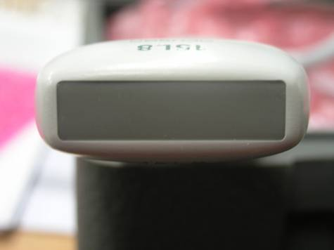 | 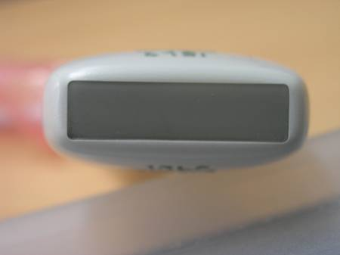 | Pass
4C1 | 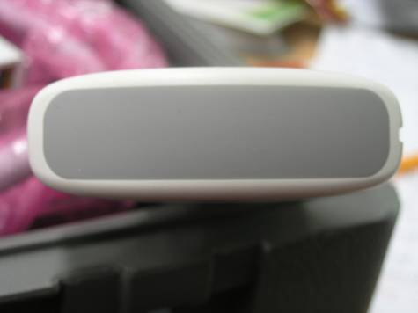 | 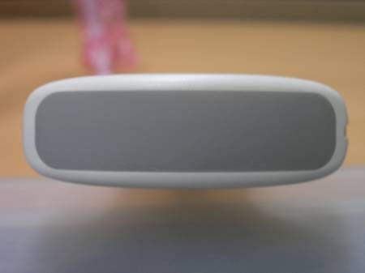 | Pass
P4-2 | 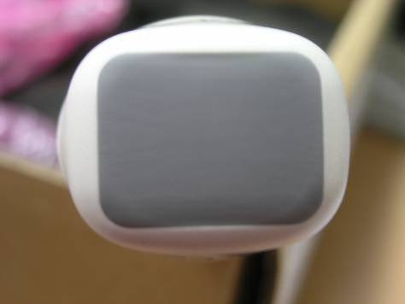 | 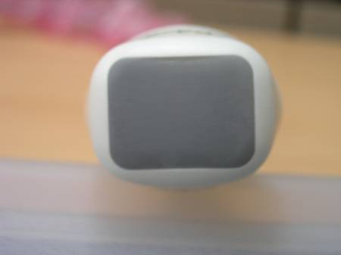 | Pass
VF13-5 | 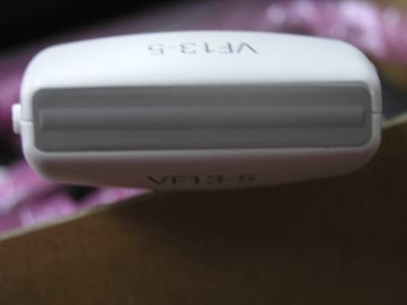 | 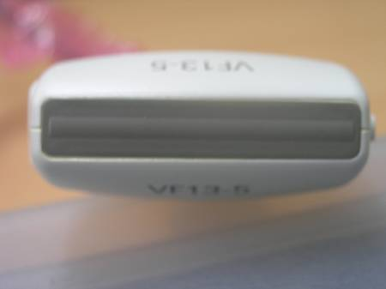 | Pass
VF13-5  (Strain Relief) | 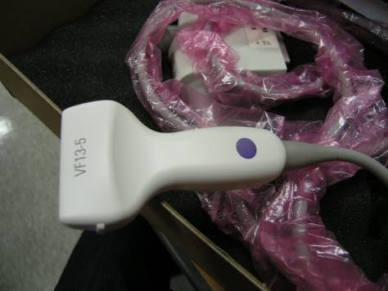 | 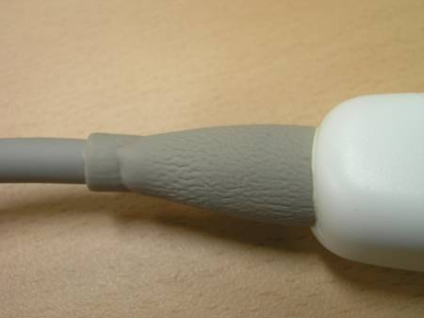 | Failed at Strain Relief
VF13-5  (Strain Relief) |  | 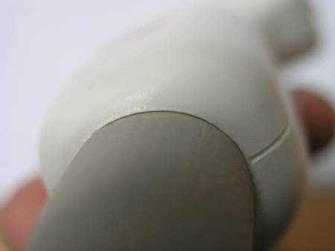  Housing case  Strain Relief | There is some crack space in btw Strain Relief and Housig case
EC9-4 | 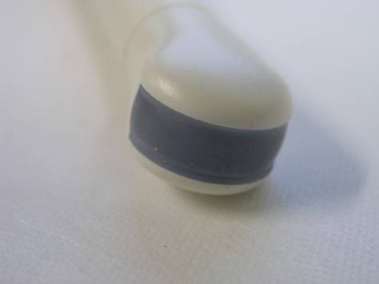 | 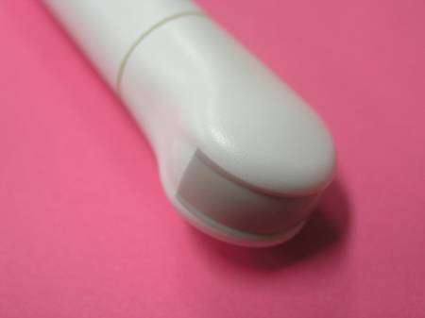 | Discoloration at Lens. It does not change probe performance.
EC9-4 | 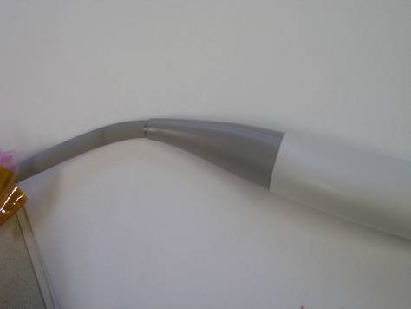 | 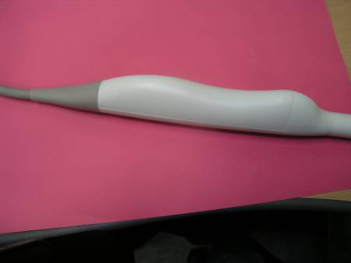 | Pass

* Probe element test & Hipot / Leakage test result
A-1). 15L8 : Before soaking
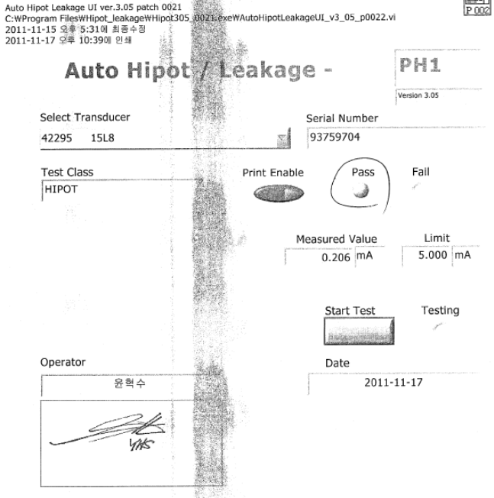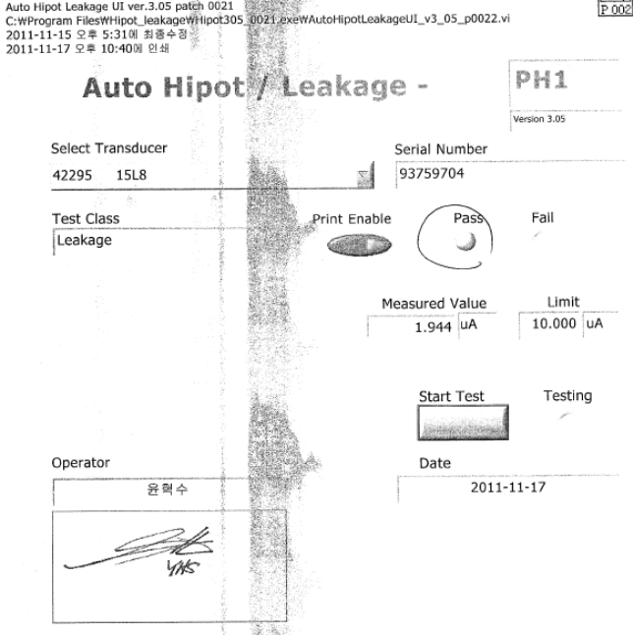

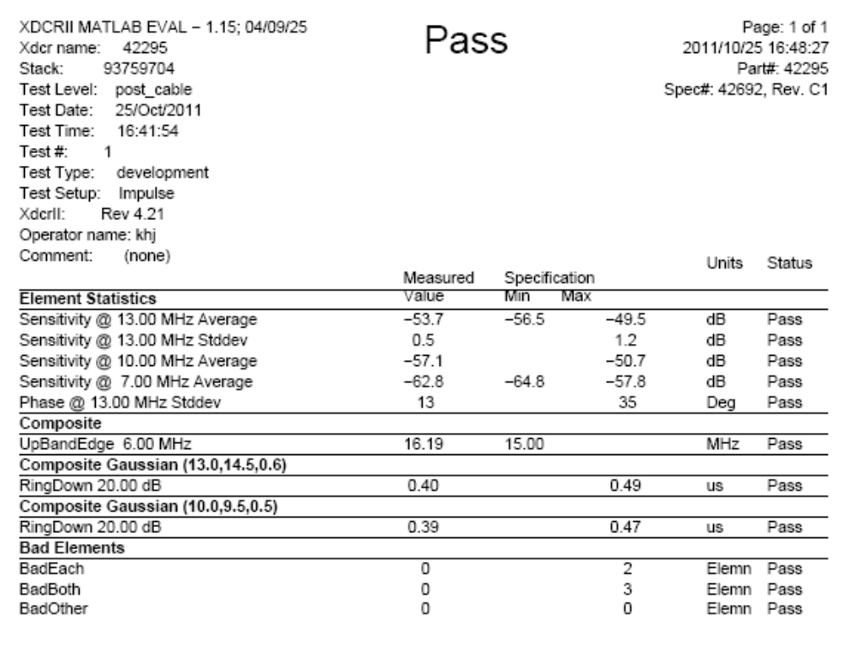
A-2). 15L8 : After soaking

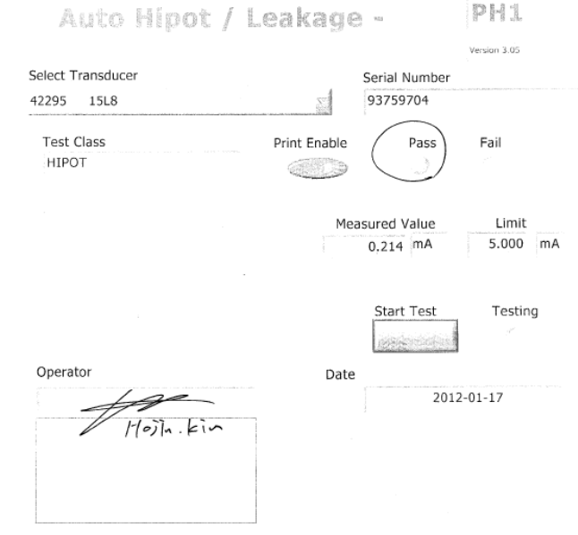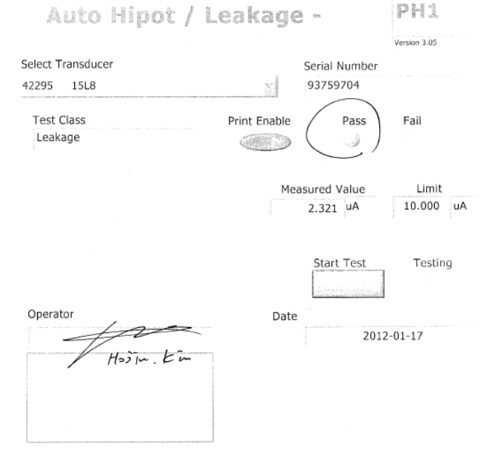

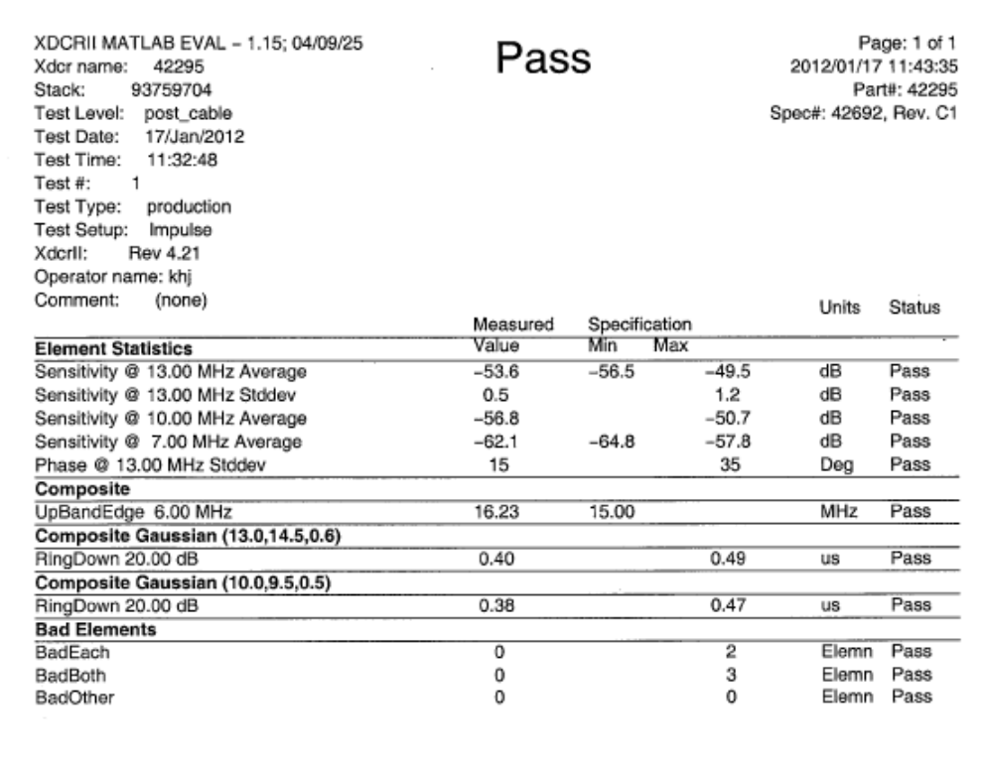
B-1) 4C1 : Before soaking

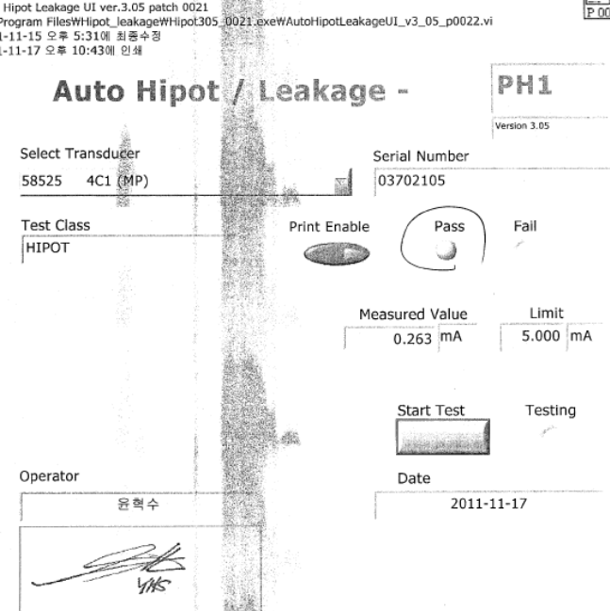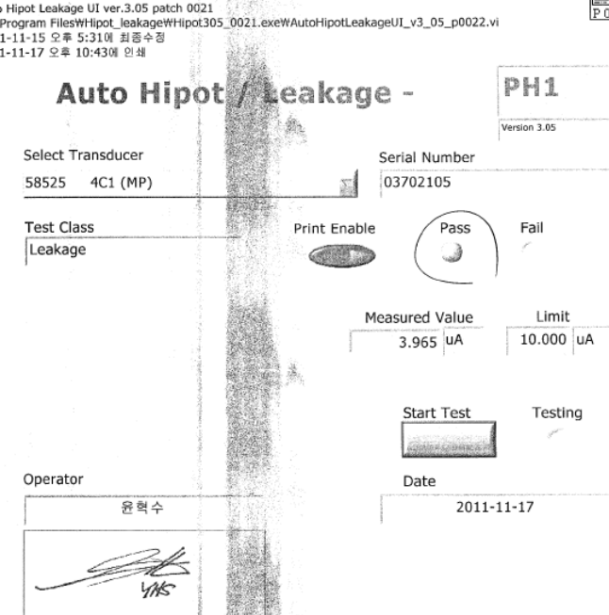

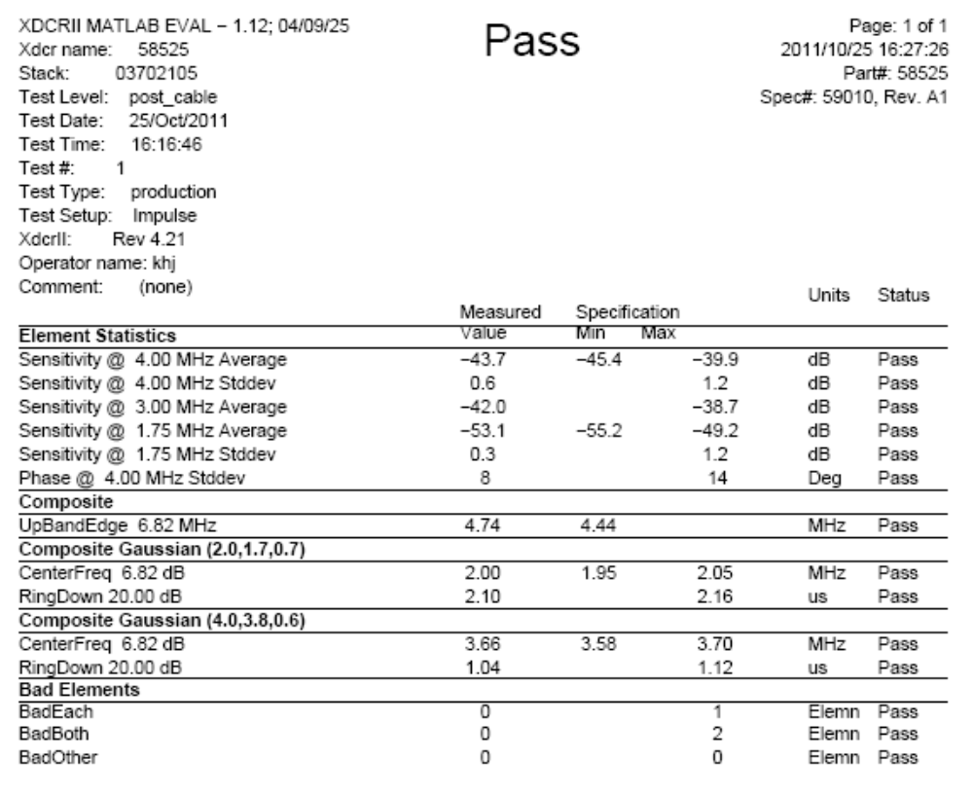
B-2) 4C1 : After soaking

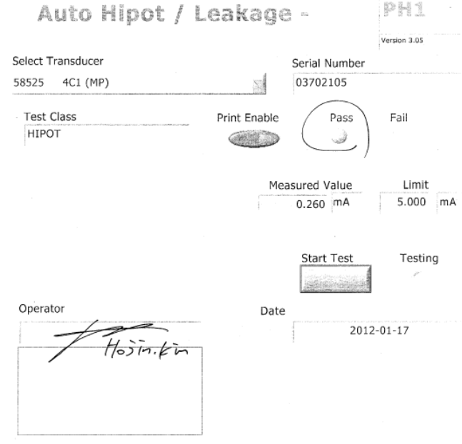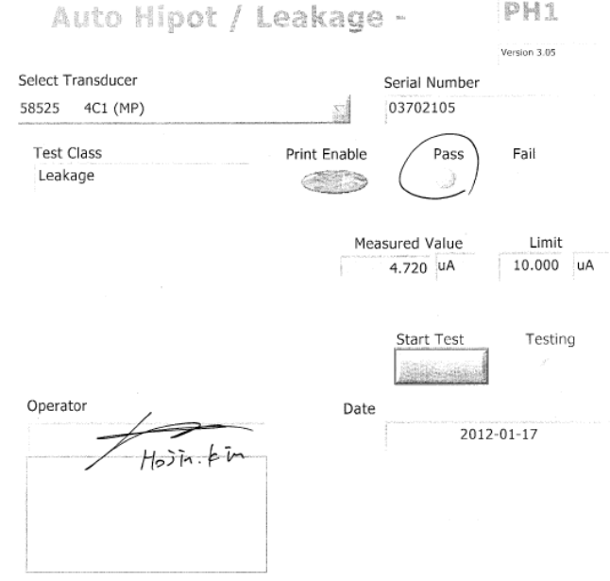

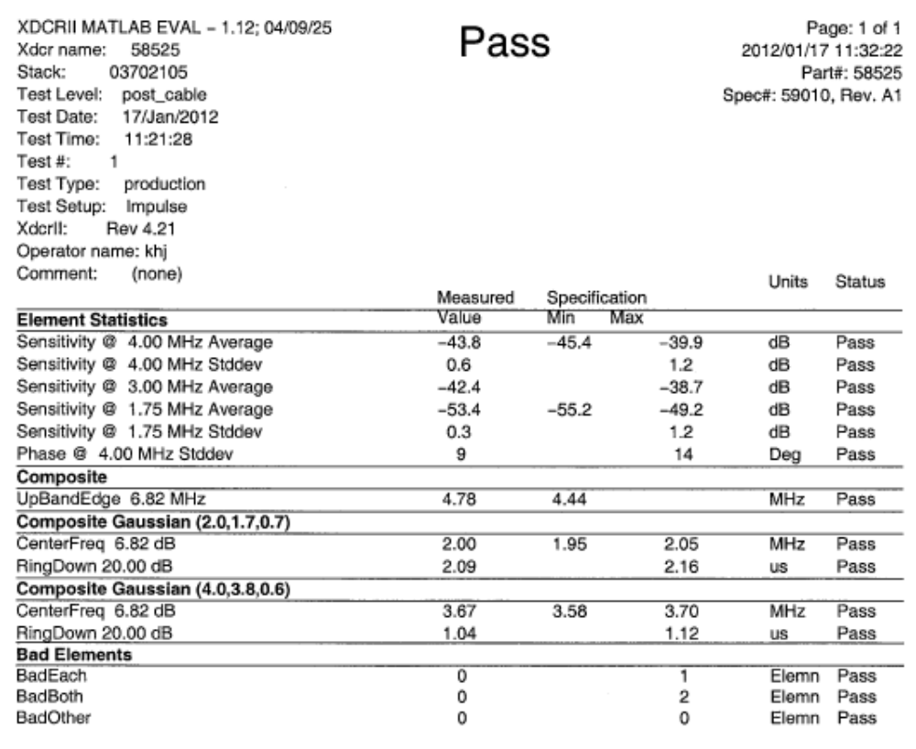
C-1) P4-2 : Before soaking

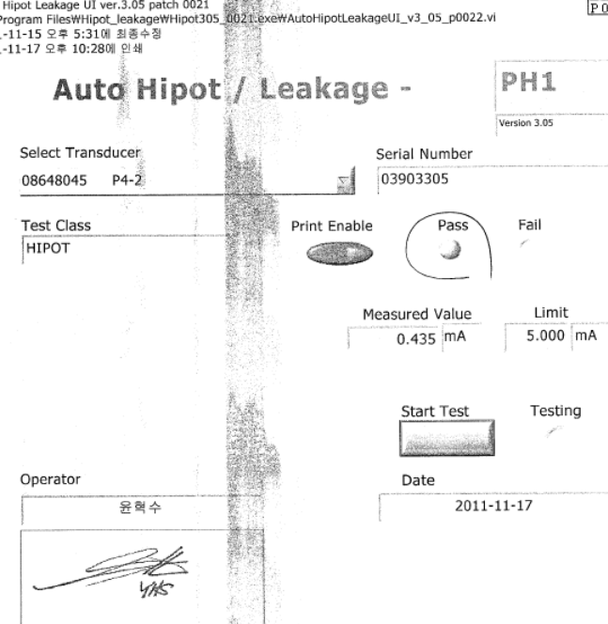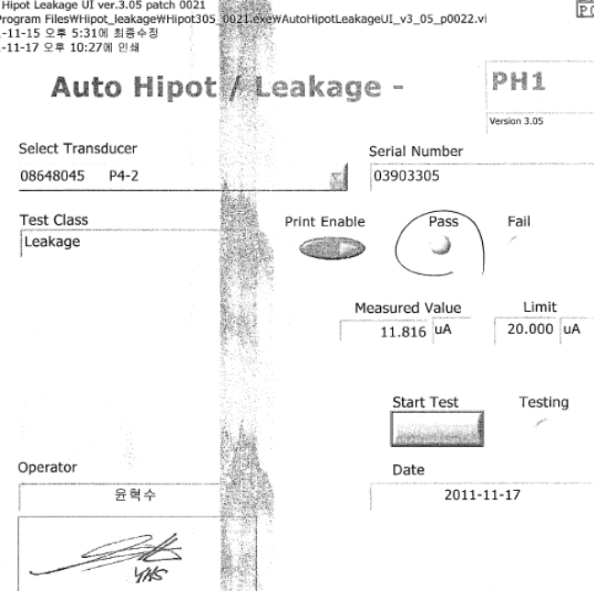

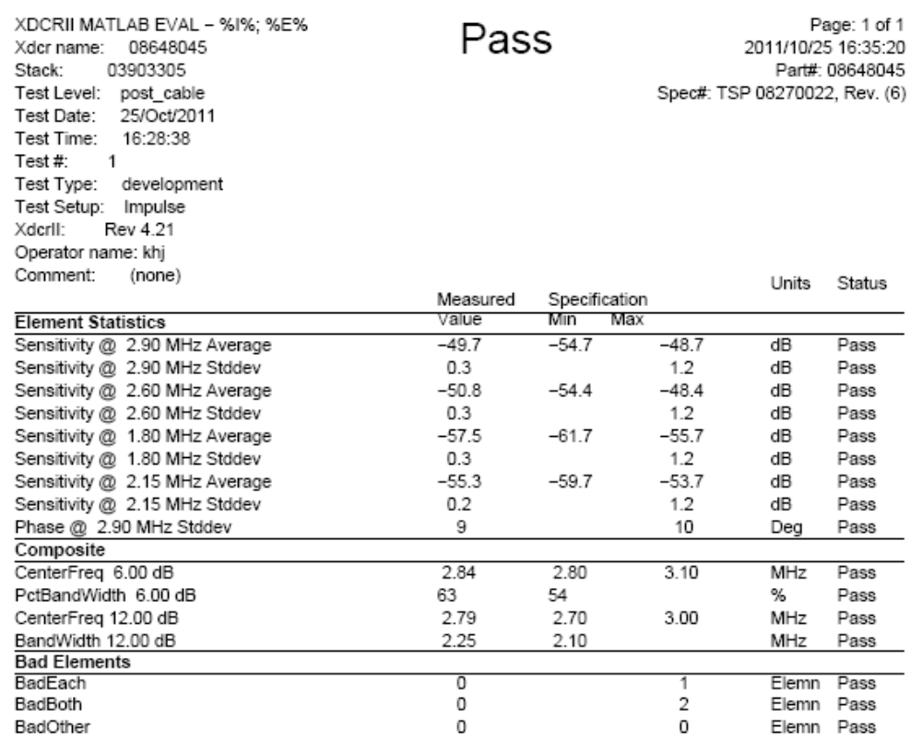
C-2) P4-2 : After soaking

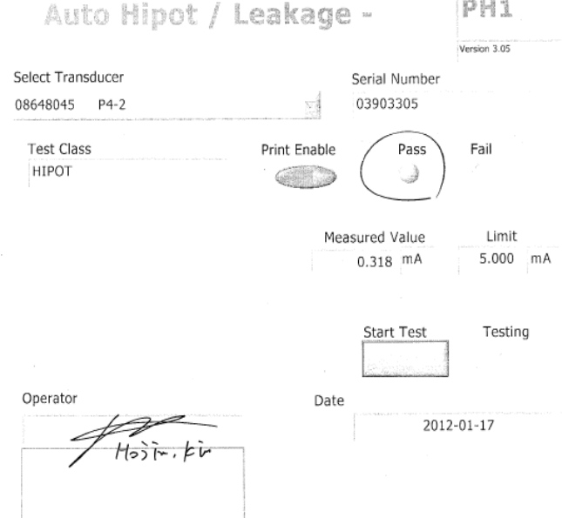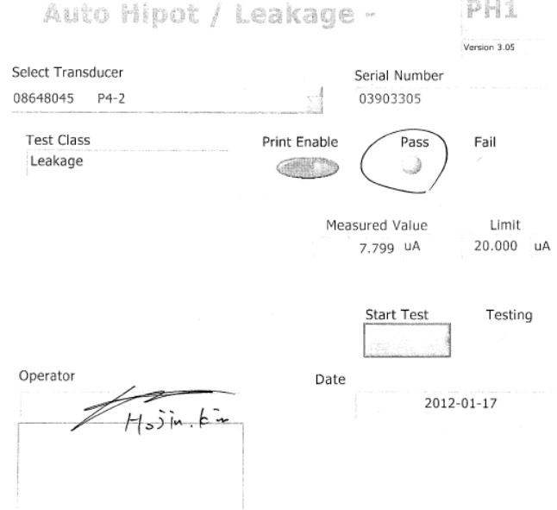

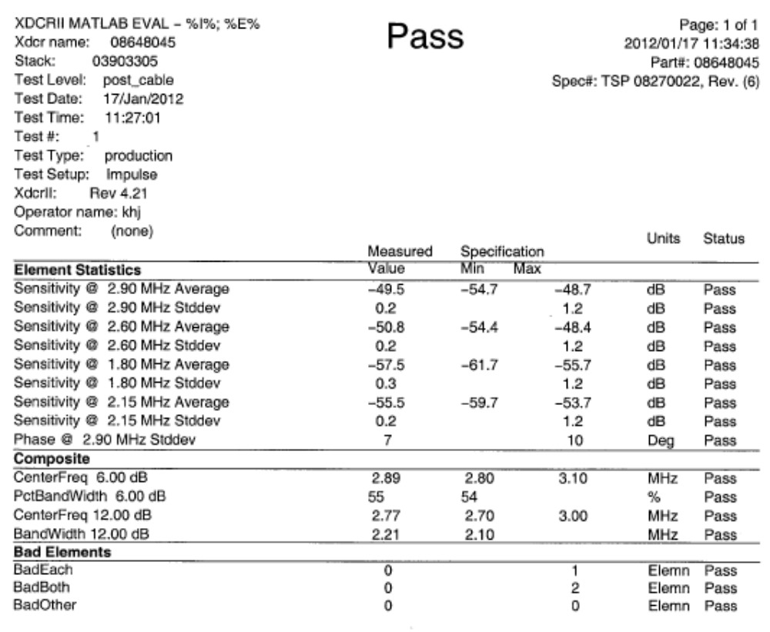

D-1) VF13-5 : Before soaking

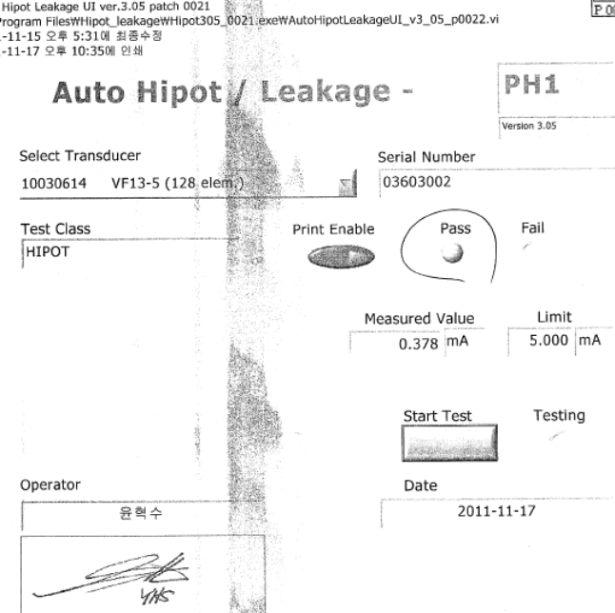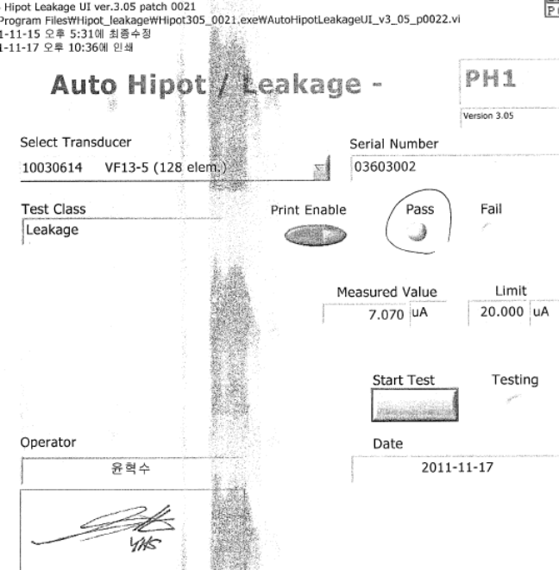

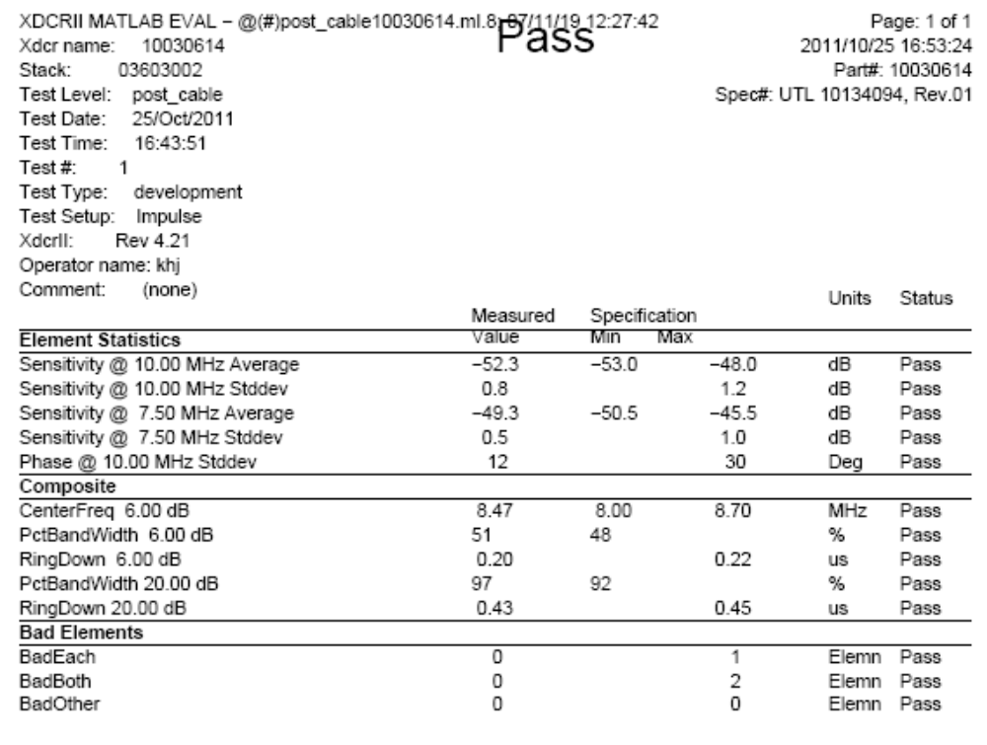
D-2) VF13-5 : After soaking

Hipot/Leakage test & XDCR test could not be done due to failed at Strain Relief by soaking test

E-1) EC9-4 : Before soaking

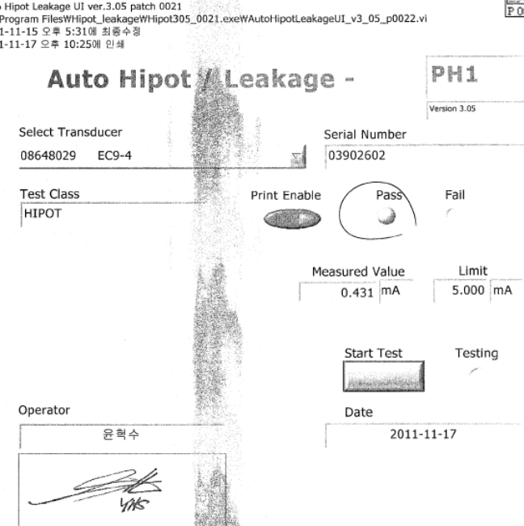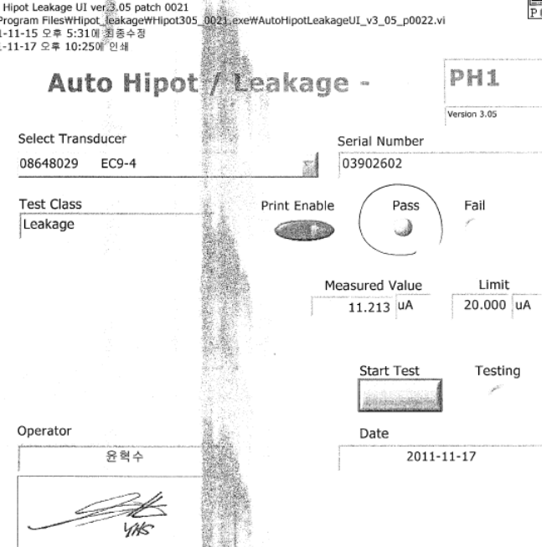

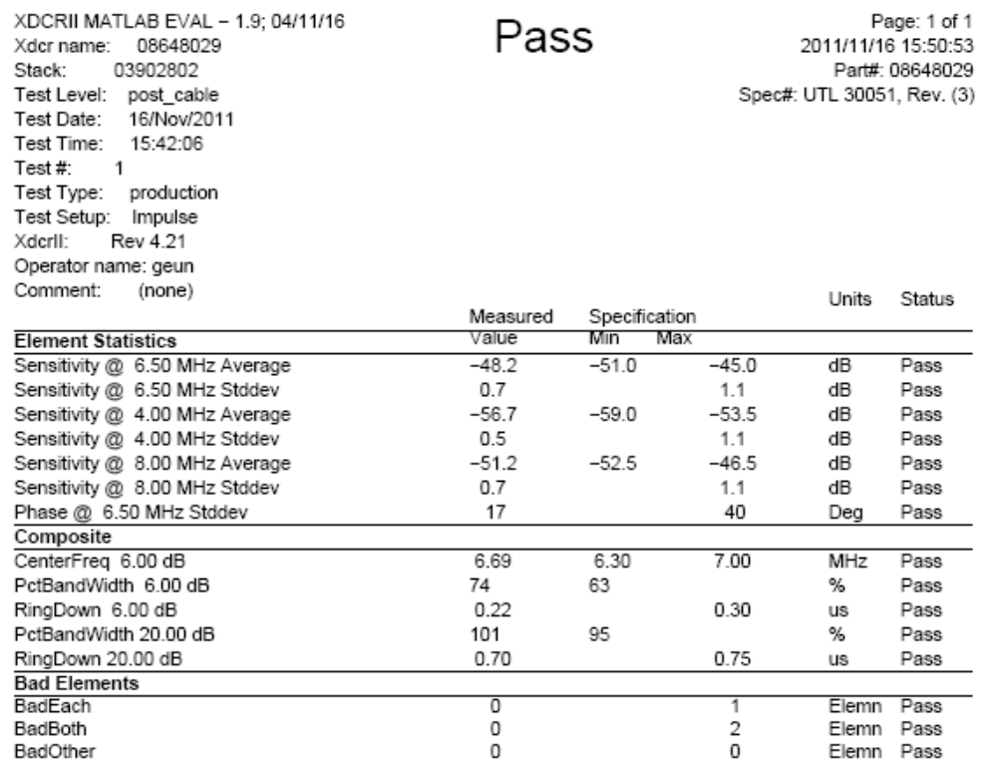
E-2) EC9-4 : After soaking

